ISSUE:
There should not be a "Delivery map" in the service order overview. instead lets just make it say service location.
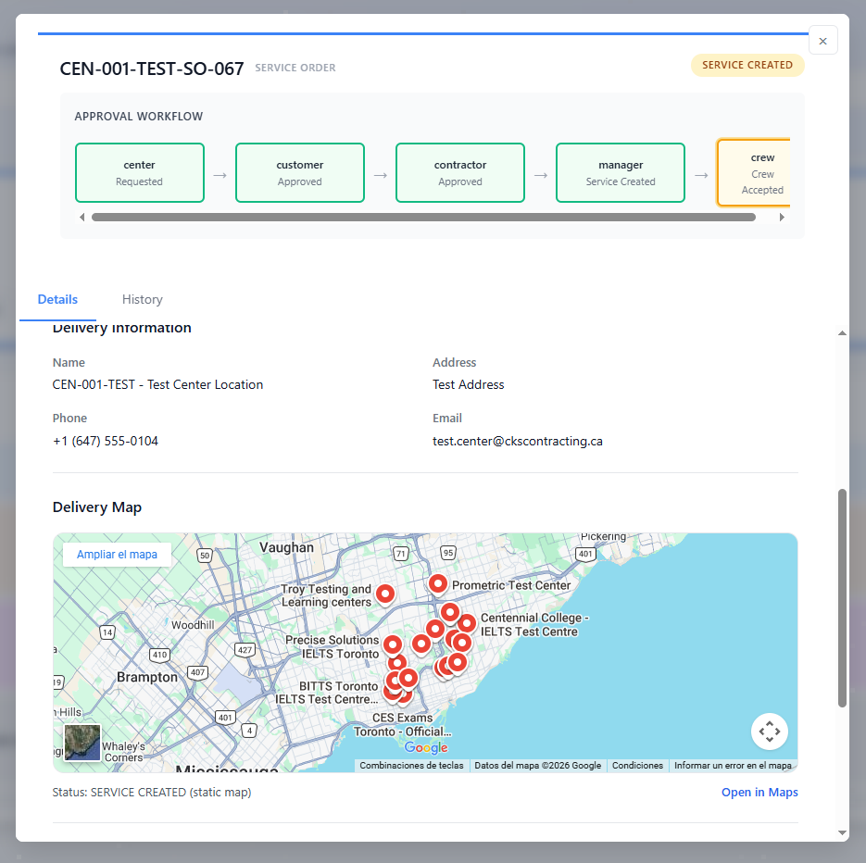

RESOLUTION:

